Efficient Multi GPU training Strategies

DDP

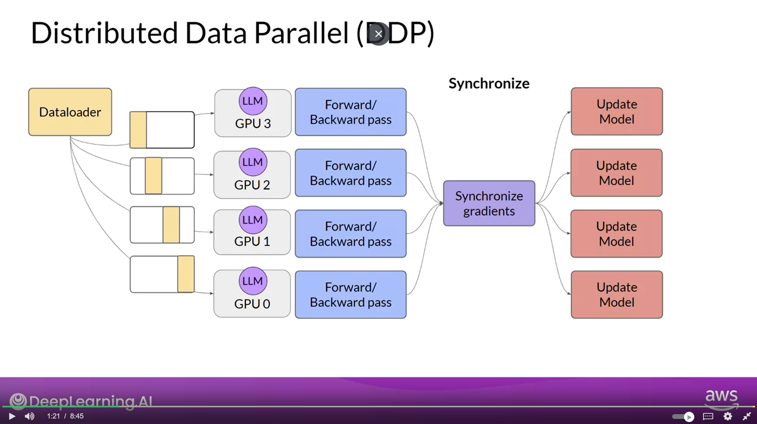

Note: DDP assumes that you model is small enough to train on sinlr GPU but you are using multiple GPUs to speed up the training process.

Fully Shared Data Parallel (FSDP) is a type of Modal Sharding

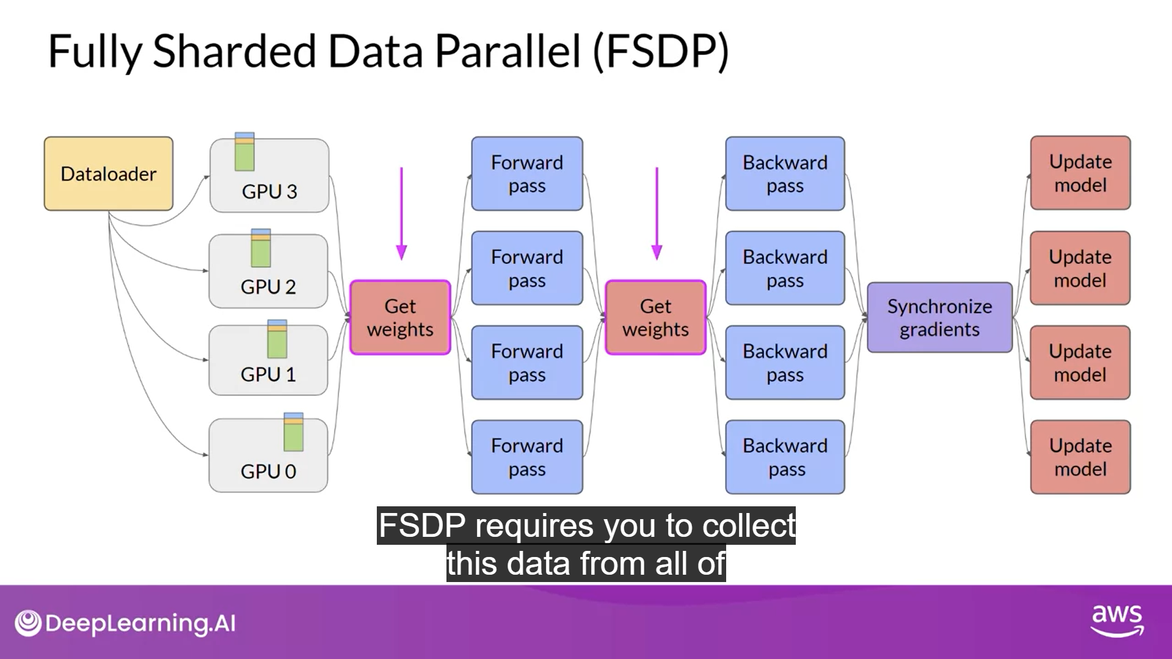

FSDP vs DDP Performance

